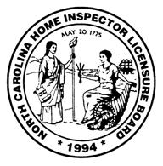
NORTH CAROLINA
HOME INSPECTOR LICENSURE BOARD
Tel (919) 647-0000 Fax (919) 715-0067 Web www.nchilb.com
Mailing Address: Location:
1202 Mail Service Center 325 N. Salisbury Street
Raleigh, NC 27699-1202 Raleigh, NC 27603

Board Members

Chairwoman:
CONNIE M. COREY
102 Leanne Drive
Greenville, NC 27858
(252) 341-9969

Vice-Chairman:
CHAD D. COLLINS
P.O. Box 2915
Durham, NC 27715
(919) 422-2818

Treasurer:
DAVID DYE
217 Dalmeny Drive
Cary, NC 27513
(919) 271-3340

Secretary:
ROBERT ROEGNER
325 N. Salisbury St.
Raleigh, NC 27603
(919) 647-0098

D. ARTHUR HALL
2261 Carolina Road
Burlington, NC 27217
(336) 227-0648

DERRICK M. JOHNSON
P.O. Box 16772
Charlotte, NC 28297
(704) 777-5061

JOSEPH B. RAMSEY, Jr.
110 West Drewry Lane
Raleigh, NC 27609
(919) 790-8000 x104

“BUTCH” UPTON, Jr.
P.O. Box 981
Belmont, NC 28012
(704) 913-3739
(888) 638-0707 (fax)

August 16, 2021

All American Training Institute
Attn: Katie Cooper
822 N A1A Highway Suite-300
Ponte Vedra, FL 32082

Re: NCHILB Pre-licensing Program Sponsor Application(s) for
120 hr. Classroom (PLC18)

Dear Ms. Cooper:

This letter confirms Board approval, effective July 7, 2021 of your Pre-licensing Classroom and Field Training Programs. This approval is based upon documentation you submitted under transmittal letter dated April 22, 2021, per the requirements of 11 N.C.A.C. 08.1023(d). Commencement of any courses or training may not begin earlier than 45 days after Board approval, in this case on or about August 21, 2010.

Please note classroom and practical training time shall be utilized for instructional purposes only and not for promoting the interests of or recruiting employees or members for any particular home inspector, home inspection firm or franchise.

The Board web site www.nchilb.com can include links for your Pre-licensing Program information. Please contact me by phone (919) 647-0022 or email Jennifer.Hollyfield@ncdoi.gov to set this up or if you have additional questions.

Sincerely,
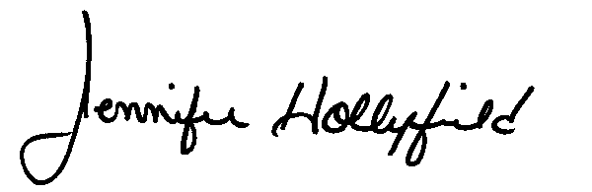
Jennifer Hollyfield
Education Coordinator,
N.C. Home Inspector Licensure Board

